NEWSLETTER OF IOW COUNTRY CLUB
June, 2023

Greetings to All,
I hope everyone had a safe Memorial Day weekend as we honored and mourned our U.S. military personnel who died while serving in the United States Armed Forces.
It’s hard to believe the first day of Summer is June 21st, yet the stores seem to be rushing time by stocking the shelves with fall and Christmas decorations.
Our next Butt/Bake Sale is scheduled for Saturday, June 24th. Don’t forget to pre-order your butts. Tickets are available. Cost is $35. Flyer attached with all the details. We’ll need some baked goods for sale at the event. We’ll also have our 50/50 Raffle.
Remember to print the flyer of monthly events. We’re excited to continue what’s working while we add a few new things along the way, like, Paint and Sip night on Saturday, June 17th.

Sincerely and Respectfully,
Kathy Loyd, President

CLUB EVENTS - Flyer for the Month of June is attached
- Just a reminder that Club (business) meetings, along with the potluck dinner will be held every other month. June 20th will be the date for this month. Dinner will begin at 6:30PM and the business meeting will begin at 7PM. Bring a dish to share (Optional).

1
Are you ready?? Isle of Wight Community Yard Sale

JUNE 17TH – SATURDAY – Begins at 9am – Please send your name and address to stockseve@hotmail.com. The information will be added to the map for participants.
Information can be found on the Isle of Wight Community page.
VOLUNTEERS
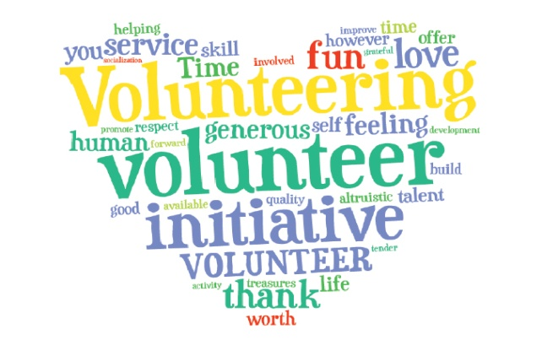
To all our volunteers…Thank you so much for volunteering. Your willingness to give your time and service is greatly appreciated.
CELEBRATING YOU!
Happy Birthday to all our Members celebrating birthdays during June!!
Happy Anniversary to all our Members celebrating their anniversary this month.
MEMBERSHIP

Welcome to our newest members:

Trish Wessel
Bernadette Strickland
Ron Edwards
Raymond Duff
Membership dues - $35- Single and $70 – Family -
Renewals - January of each year.

Emma Reid, Chairperson of the Membership Committee –
Contact information – iowmembershipga@gmail.com

THINKING OF YOU!

WE’RE HERE FOR YOU. Please contact Robyn Carradine if you know of a member who may be ill, lost a loved one, or just needs a little assistance. We’re here to help out.
Robyn’s contact information:
Phone: 912-312-9440 Email: robyn.carradine1958@gmail.com

2

PAINT AND SIP EVENT June 17 @ 6:00 pm – 9:00 pm

Choice of Crab, Heart with Stars, or Floral Circle.
- $40 Members/$45 Non Members
- Pre-Registration and payment required.
- Options for Touch Up assistance or you can sit back while the pros paint for you. BYOB
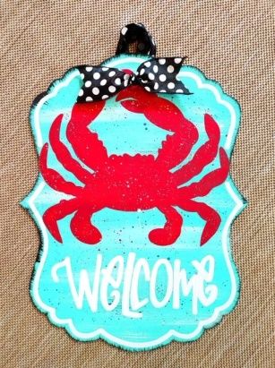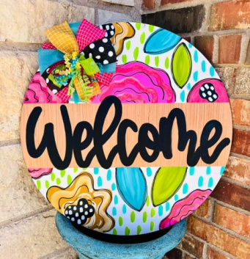

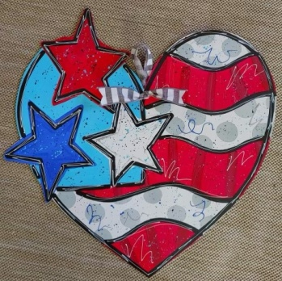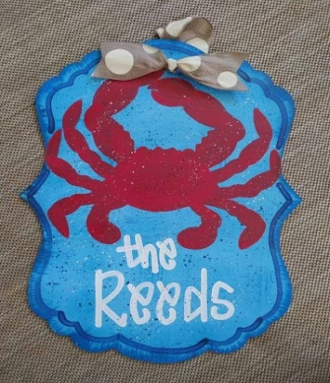

Looking forward to seeing you!
Should be a fun evening.
Sign up on the IOW Country Facebook page

3

BOOK CLUB
June 28th – Wednesday – Join us for a discussion on this book.

The Nightengale - Author: Kristin Hannah– BOOK FOR JUNE

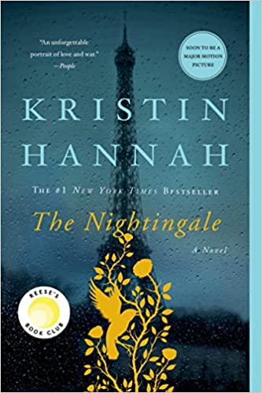

Summary
“ A #1 New York Times bestseller, Wall Street Journal Best Book of the Year, and soon to be a major motion picture, this unforgettable novel of love and strength in the face of war has enthralled a generation.
France, 1939 - In the quiet village of Carriveau, Vianne Mauriac says goodbye to her husband, Antoine, as he heads for the Front. She doesn't believe that the Nazis will invade France … but invade they do, in droves of marching soldiers, in caravans of trucks and tanks, in planes that fill the skies and drop bombs upon the innocent. When a German captain requisitions Vianne's home, she and her daughter must live with the enemy or lose everything. Without food or money or hope, as danger escalates all around them, she is forced to make one impossible choice after another to keep her family alive.
Vianne's sister, Isabelle, is a rebellious eighteen-year-old girl, searching for purpose with all the reckless passion of youth. While thousands of Parisians march into the unknown terrors of war, she meets Gäetan, a partisan who believes the French can fight the Nazis from within France, and she falls in love as only the young can … completely. But when he betrays her, Isabelle joins the Resistance and never looks back, risking her life time and again to save others.
With courage, grace, and powerful insight, bestselling author Kristin Hannah captures the epic panorama of World War II and illuminates an intimate part of history seldom seen: the women's war. The Nightingale tells the stories of two sisters, separated by years and experience, by ideals, passion and circumstance, each embarking on her own dangerous path toward survival, love, and freedom in German-occupied, war-torn France―a heartbreakingly beautiful novel that celebrates the resilience of the human spirit and the durability of women. It is a novel for everyone, a novel for a lifetime.
Goodreads Best Historical Novel of the Year • People's Choice Favorite Fiction Winner • #1 Indie Next Selection • A Buzzfeed and The Week Best Book of the Year”

4

