NEWSLETTER OF IOW COUNTRY CLUB
July, 2023

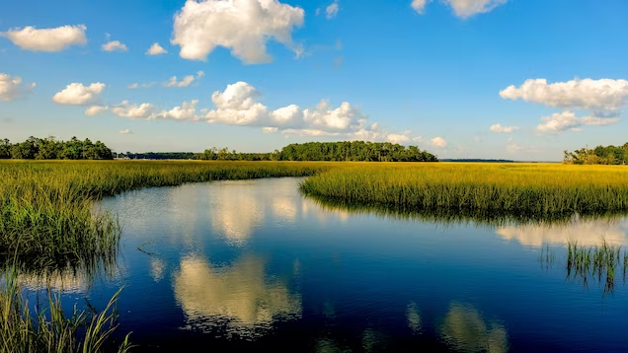

Greetings to All,
I would like to start off by saying “Thank you” to all our volunteers who helped with the Butt/Bake sale and 50/50 Raffle. We couldn’t have done it without you.
If you haven’t already heard, the Paint and Sip party held in June was a huge success. So, I’m happy to report we’ve already scheduled another event for September. There will be seasonal designs to choose from. Watch for updates and be sure to register.
Our July events flyer is attached and has been posted for your convenience. Join us for Movie Night on Friday, July 7th following our potluck dinner.
We’re looking forward to the 4th of July celebration on Dolphin Island. Thank you Allen Harwood for coordinating this annual event. For those attending, please bring a covered dish for the potluck picnic. Donations for fireworks are being accepted by Allen for this community event.
Summer has arrived and the temperatures are rising. Please take care of yourself and your pets.
Sincerely and Respectfully,
Kathy Loyd, President
CLUB EVENTS - Flyer for the Month of July is attached
- (NEW) Movie Night – Friday, July 7th; follows the Potluck Dinner. Please join us. We’ll be showing Top Gun, Maverick
- Reminder - Club (business) meetings, along with the potluck dinner will be held every other month. The next club meeting night is Tuesday, August 16th.

1
VOLUNTEERS
Thank you to all the volunteers who helped out with the Butt/ Bake Sale and 50/50 Raffle! So much goes into the planning, coordination and implementation for these fundraising events. We succeeded because of you!. All tickets were sold, the butts were delicious and what a wonderful selection of baked goods we had. The rain held off for the most part. Congratulations to Tracie and Boe, winners of the 50/50 Raffle. Our next Butt and Bake Sale is scheduled for September.
To all our volunteers…Thank you so much for volunteering. Your willingness to give your time and service is greatly appreciated.
CELEBRATING YOU!
Happy Birthday to all our Members celebrating birthdays during July!!
Happy Anniversary to all our Members celebrating their anniversary this month.
MEMBERSHIP

Welcome to our newest member(s): - Amy Phelps

Membership - $35- Single and $70 – Family
Renewals - January of each year.

Emma Reid, Chairperson of the Membership Committee

Contact information – iowmembershipga@gmail.com

MEET AND GREET
Do you know someone new on the island? A new member of the club? What a great opportunity to get to know more people in our community and introduce them to our club! Mark your calendar for July 13th, Thursday. Bring a friend, new resident, or neighbor. We’d love to get to know you, answer questions, hear your ideas. And if you’re not already a member, maybe you’d like to join.

THINKING OF YOU!
- Healing prayers to a few of our members who are feeling a bit under the weather. Take care and we hope you all will be feeling better soon.
- Sincere condolences to the family of Josh Gill who died as a result of a boating accident at Jones Creek bridge. A candlelight vigil was held 7/2.

WE’RE HERE FOR YOU. If you know of a member who may be ill, lost a loved one, or just needs a little assistance, we’re here to help. Please contact Robyn Carradine.
Robyn’s contact information:
Phone: 912-312-9440 Email: robyn.carradine1958@gmail.com

2

BOOK CLUB

Would you like to have some fun? Come join us on Wednesday, July 26th from 7-9pm for a discussion on our newest book selection.

The 100-Year Old Man who climbed out the window and disappeared.
Author: Jonas Jonasson

Summary –

A larger-than-life old man with a fondness for vodka goes on an unexpected adventure in this whimsical novel -- perfect for fans of Forrest Gump and A Man Called Ove.
The international publishing sensation -- more than six million copies sold worldwide!
A reluctant centenarian much like Forrest Gump (if Gump were an explosives expert) decides it's not too late to start over . . .

It’s Hot, Hot, Hot!

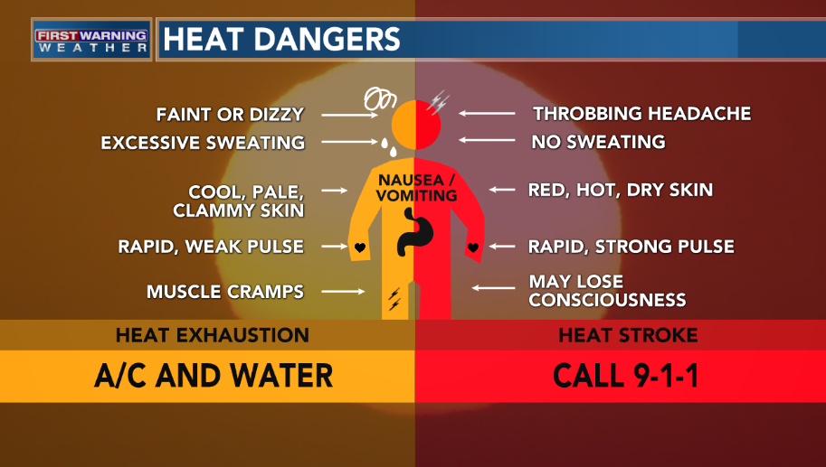

3

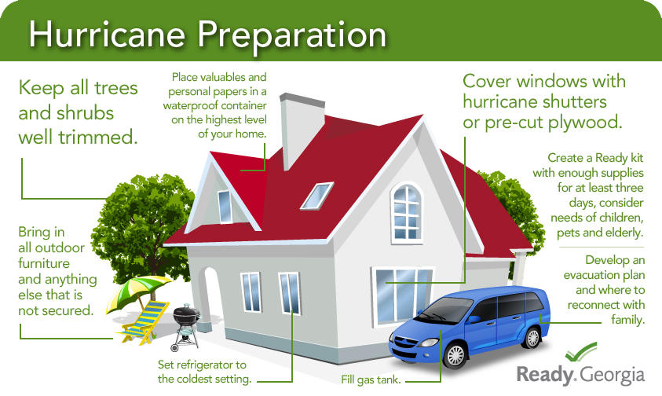

It’s never to early to prepare…

Fireworks can be stressful for humans and pets. Take precautions.

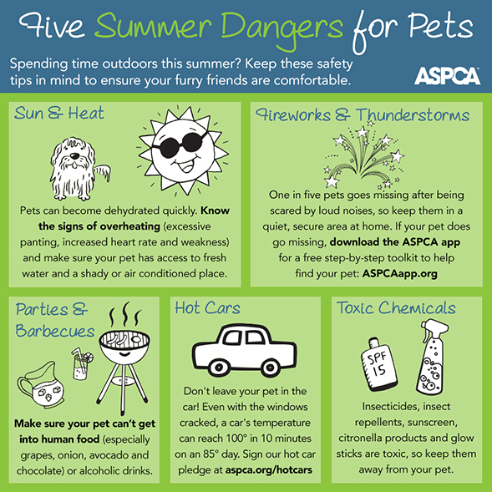

4

